Create 4 ec2 instances. 1 is Master and another 3 is slaves and then connect the instances to the terminal for deploying **WordPress**, **M-Ticket**, **Python application**.

* **Slave Configuration:**

Create User, ssh keys and copy it to authorized_keys.

* sudo apt install default-jre -y
* sudo adduser slave1
* sudo su slave1
* ssh-keygen -t rsa -N “ ” -f /home/slave1/.ssh/id_rsa
* cd .ssh/
* cat id_rsa.pub > authorized_keys
* chmod 700 authorized_keys
* **Master Configuration:**

Copy the Slave node’s public key to master node’s known_hosts file

* sudo apt install default-jre -y
* curl -fsSL https://pkg.jenkins.io/debian/jenkins.io-2023.key | sudo tee \
* /usr/share/keyrings/jenkins-keyring.asc > /dev/null
* echo deb [signed-by=/usr/share/keyrings/jenkins-keyring.asc] \
* https://pkg.jenkins.io/debian binary/ | sudo tee \
* /etc/apt/sources.list.d/jenkins.list > /dev/null
* sudo apt-get update
* sudo apt-get install Jenkins
* sudo mkdir -p /var/lib/Jenkins/.ssh
* cd /var/lib/Jenkins
* sudo chmod 777 .ssh/
* cd .ssh/
* sudo ssh-keyscan -H SLAVE_NODE_PRIVATE_IP >>/var/lib/Jenkins/.ssh/know_hosts
* sudo chown 700 known_hosts

1. Configure these commands for Master

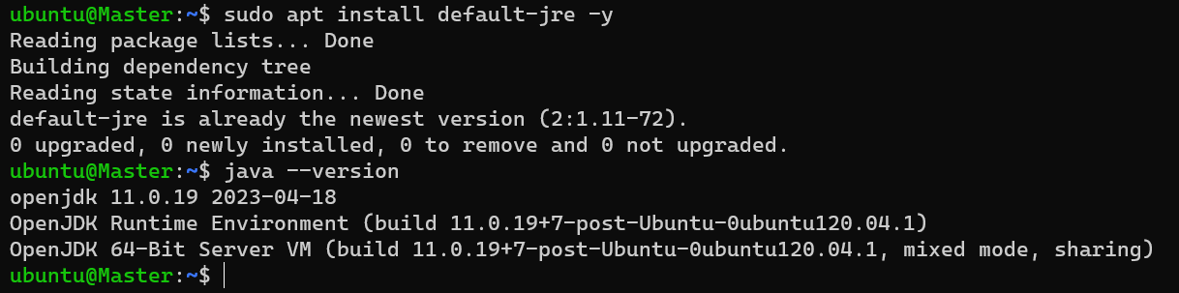

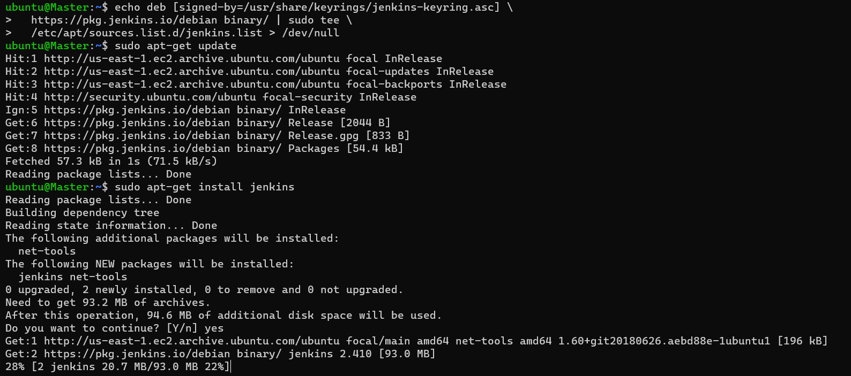

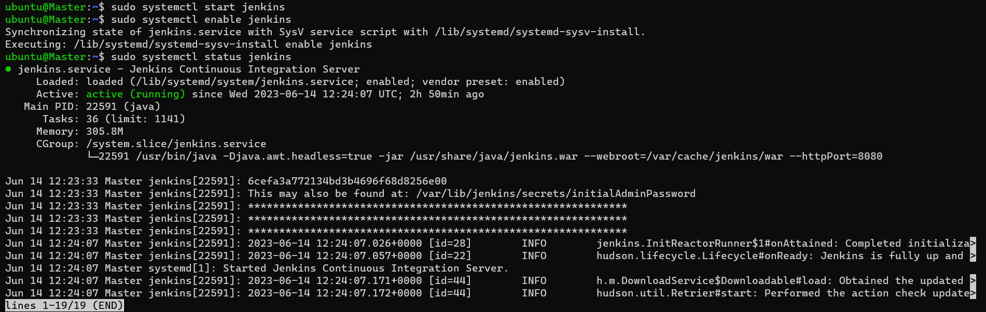

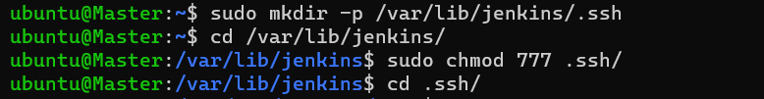

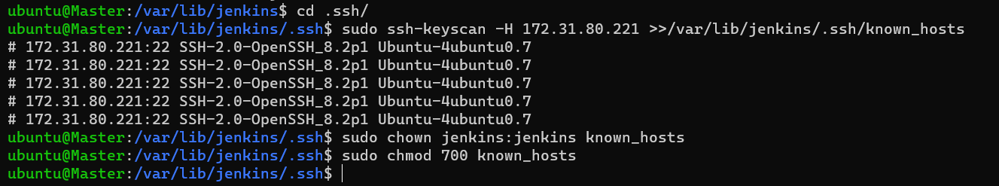

1. Configure these commands for slave

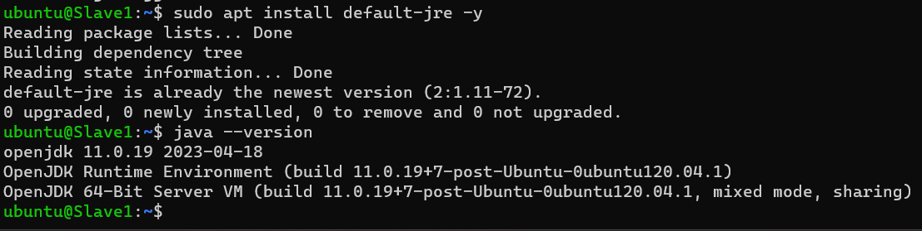

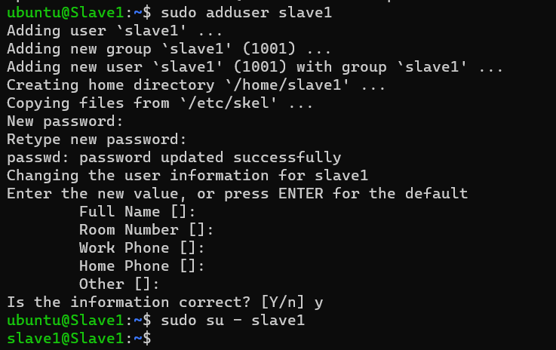

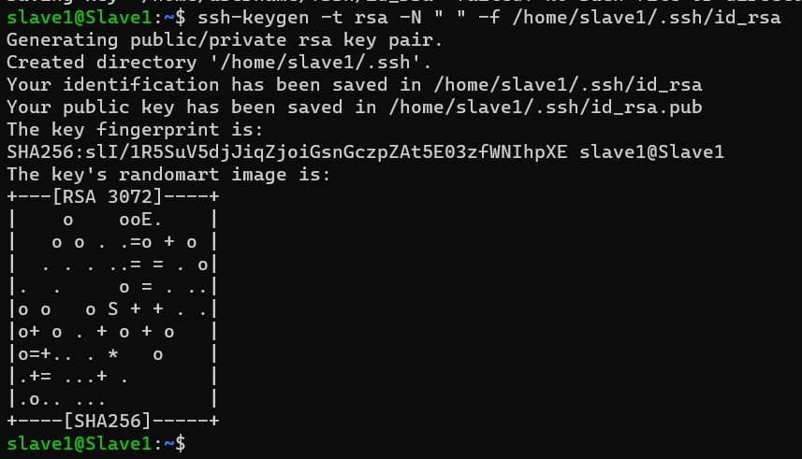

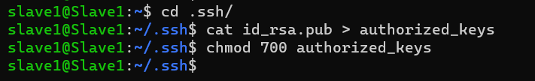

* Word press
* Create a node

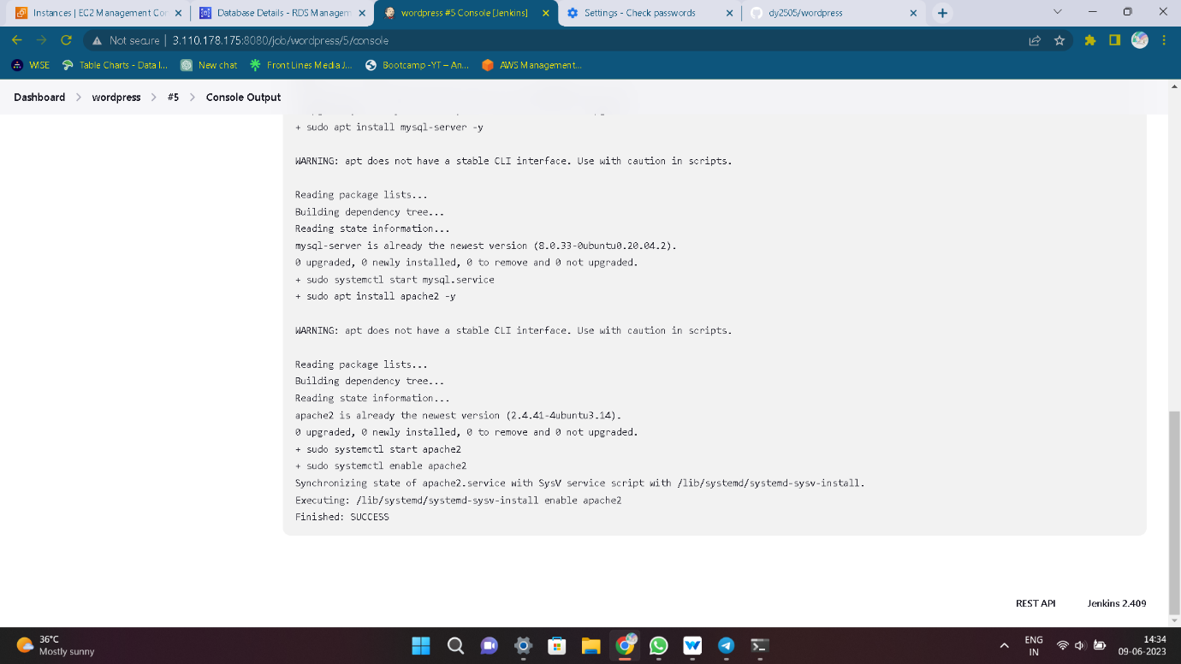

* Now create a free style project
* For deploying WordPress. give those commands in execute shell
* After build the job. If the console output is success, your job is done.
* Go to the console and give security group is port is 80
* Now copy the public ip4 and browse it.
* Public ip : port number

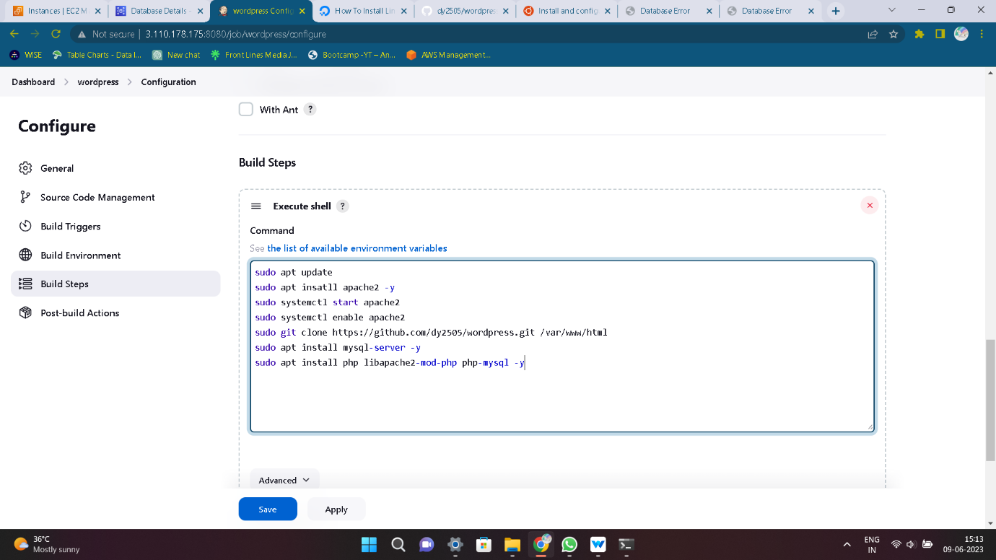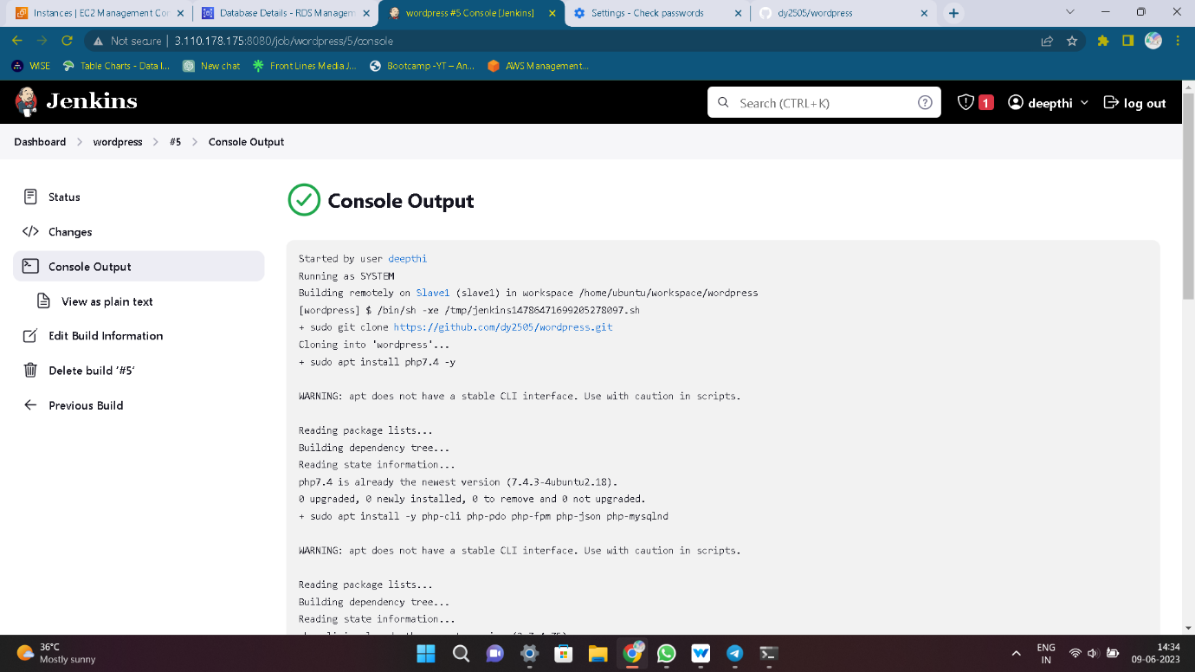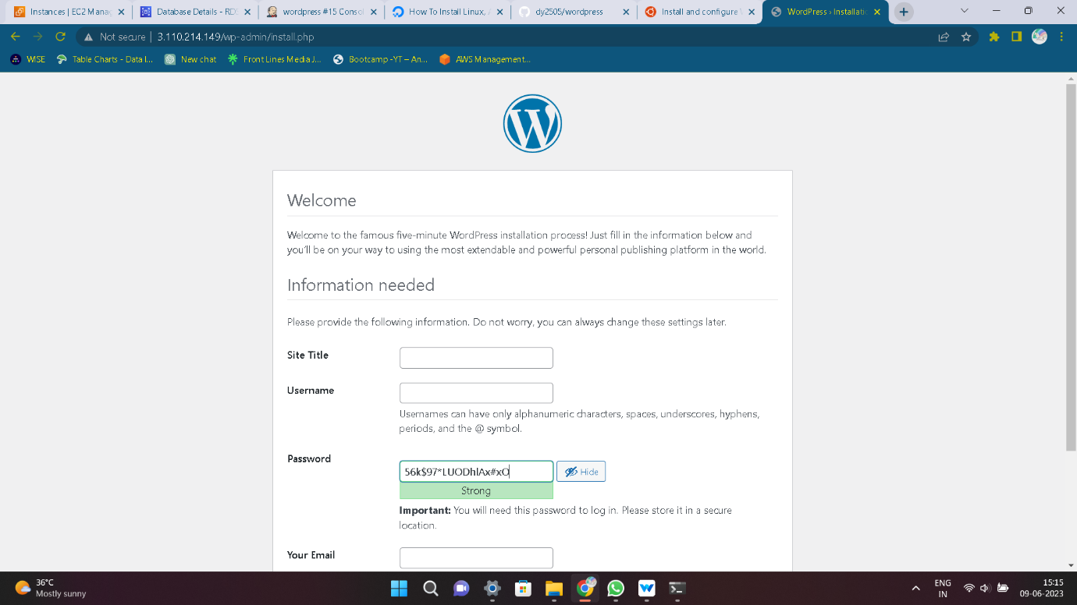

* M-Ticket
* Create a node

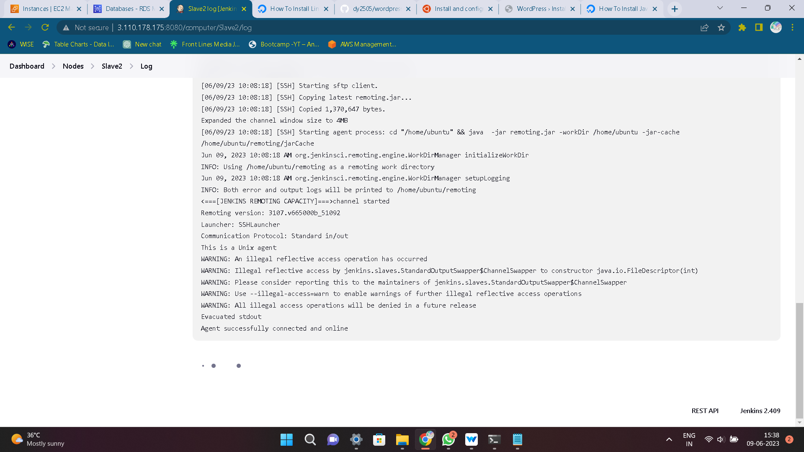

* Now create a free style project
* For deploying M-Ticket. give those commands in execute shell
* After build the job. If the console output is success, your job is done.
* Go to the console and give security group is port is 80
* Now copy the public ip4 and browse it.
* Public ip : port number

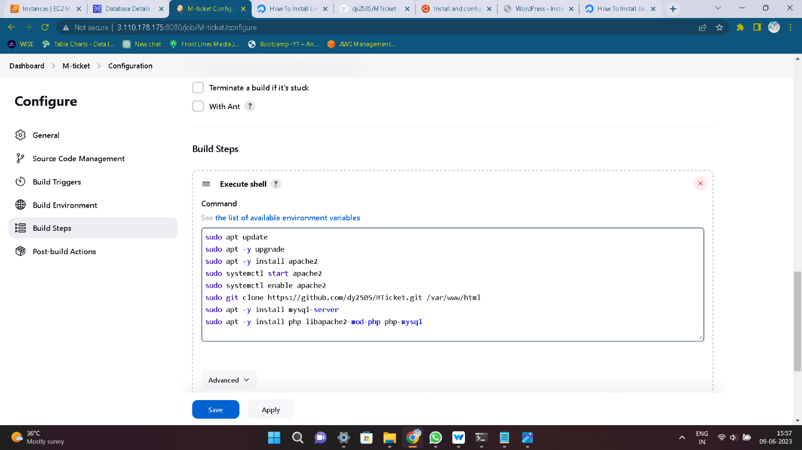

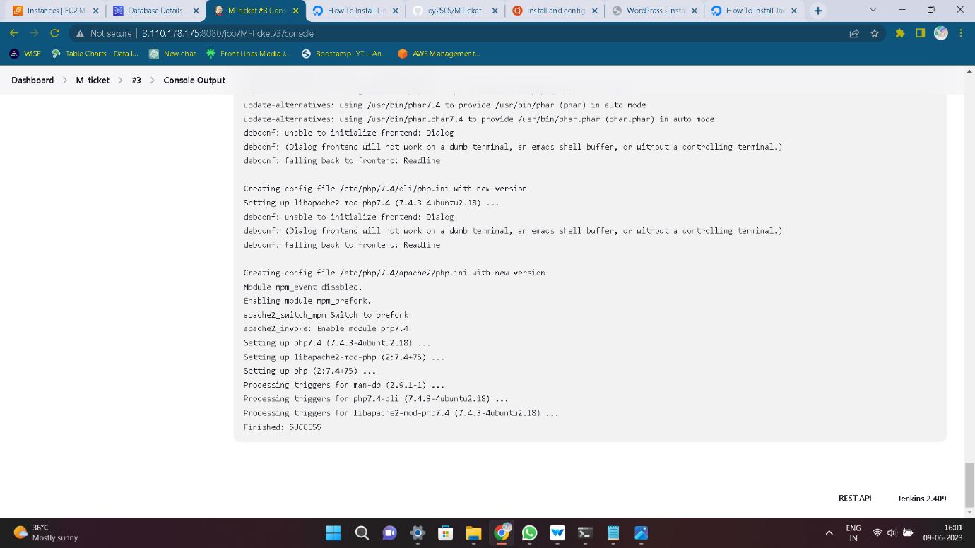

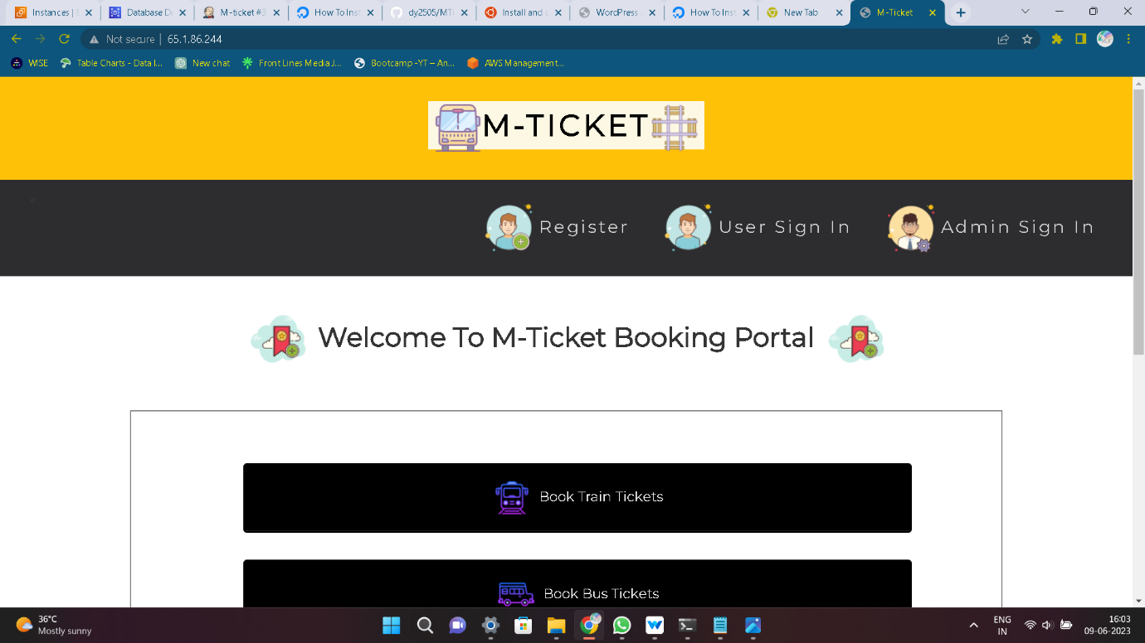

* Python Application
* Create a node

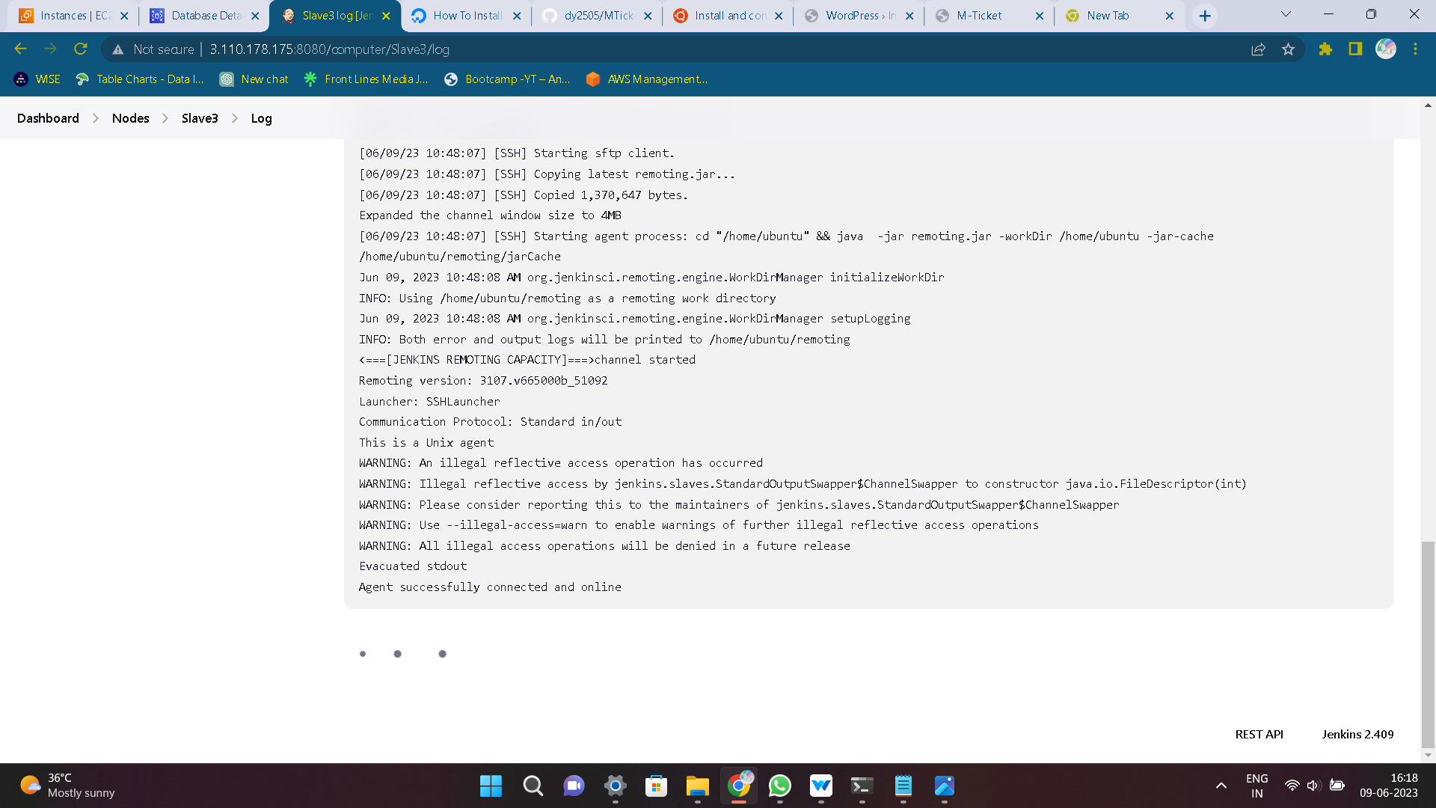

* Now create a free style project
* For deploying WordPress. give those commands in execute shell
* After build the job. If the console output is success, your job is done.
* Go to the console and give security group is port is 80
* Now copy the public ip4 and browse it.
* Public ip : port number

